International Conference On Advanced Technology and Adoption Methods in
Science and Engineering
(ICATAMSE-2024)
ISBN:978-81-969383-0-7
Chief Patron Mr. M.R. Bhumkar
President, SRCOE, Pune
Convener
Prof. Dr. K. Sujatha Principal, SRCOE, Pune Secretary
Prof.V.M.V. Venkateswara Rao
HoD Electrical Engineering, SRCOE, Pune
Keynote Speakers Mr. Mahesh Kumar Roy
Sc G and Group Director CEMS, R&DE(E), DRDO -Pune Session Chair
Dr. Nagendra Kushwaha, IIIT Pune Dr. Sanjeev Sharma, IIIT Pune
Coordinators
Advisory Board
Dr.Suryakanth ,ECE Dept,BKIT,Bhalki.
Dr. Prashant Sangulgi ,ECE HOD,BKIT,Bhaiki. Dr. Kalpana Chikatwar ECE,Bhalki
Dr. Saumya R. Mohapatra,Physics Dept,NIT Silchar. Dr. Ujwala Baruah,CSE Dept,NIT Silchar.
Dr. Madumita Banerjee,ECE Dept,NIT Silchar. Dr. Ram Kumar Karsh ,ECE Dept,NIT Silchar. Dr.APARUP BISWAL,Civil Dept,NIT goa.
Dr.Renu Dhir ,CSE Dept,NIT Jalandhar. Dr.Neelam Ghuge ,EE Dept,BSIOT,Pune.
Dr. Sanjeev Singh ,Electrical Dept ,NIT Bhopal. Dr.Siddartha Deb Roy ,Electrical Dept ,NIT Bhopal
Dr. Shivendra K.Chauragsiya ,Science Dept. NIT Bhopal. Dr. Amit Suhana ,Mech Dept. NIT Bhopal.
Dr.Jay Prakash Singh ,Electrical Dept,VNIT Nagpur. Dr.Nidhi Lal ,CSE Dept,VNIT Nagpur.
Dr.Sachidananda Prasad, Electrical Dept,NIT Odisha. Dr.Asha Shendge ,Electrical Dept,GHRCEM,Pune.
Dr.Sangita Patil , Electrical dept ,MIT School Pune Dr.Pragati Korde ,Electrical dept ,GHRCEM ,Pune . Dr.Priti Yogesh Kamble ,Zoology dept ,SCC Pune Dr.V.M.Panchade ,Electrical Dept, GHRCEM ,Pune .

Shree Ramchandra College of Engineering, Pune
Organized By

Department of Electrical Engineering Shree Ramchandra College of Engineering Lonikand ,Pune Wagholi-4122207

Reach out us for assistance
Prof.V.M.V. Rao. Ph No 7276317328

Venue
Shree Ramchandra College Of Engineering
Gat No. 351, Lonikand, next to BJS, off Nagar Road,

Mrs. Purohit .J
Mrs. Priya R. Patil Mr.D.K.Nemane
Dr. Mukesh Pushkarna ,Electrical Dept ,GLA University ,Mathura.
Mrs.Sayali Gote Mrs.Snehal Kolape
Dr.Mohit Bajaj ,Electrical Dept,Graphic Era ,Dehradun . Dr. Worakamol Wisetsri, Thailand
Pune - 412216
www.srespune.org


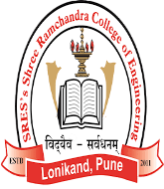




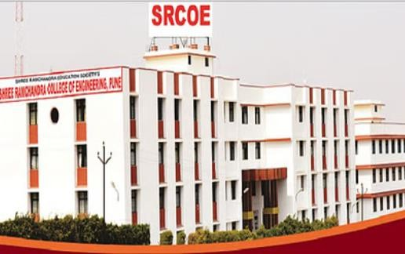

About SRCOE
“Shree Ramchandra College of Engineering” (SRCOE) was established in the academic year 2011-2012 under the aegis of “Shree Ramchandra Education Society”, Pune, with a clear objective of providing technical education, with high standards.
The college is recognized by AICTE, New Delhi and DTE, MSBTE, Govt. of Maharashtra and is affiliated to Savitribai Phule Pune University, Pune. The college has obtained the permission to run four years engineering degree courses in Mechanical, Civil, Computer, and Electrical, E & TC Engg. The college provides excellent academic and socio-economical environment to the students. The college has developed state of art infrastructure, comprising of well equipped laboratories, a resourceful library with sufficient number of reference, text and hand books, excellent class rooms, adequate parking space, sport facilities and hygienic cafeteria etc. The facilities create conducive environment for teaching-learning process. The college has appointed well qualified, experienced (academic and industrial), result oriented teaching faculties, supporting staff and administrative staff who are committed and devoted, which helps for the overall growth and development of the student and college.

SRES’s Shree Ramchandra College of Engineering

Conference Scope
Aeronautical Engineering, Aerospace Engineering, Agricultural Engineering, Architecture and Planning, Audio Engineering, Automotive Engineering, Biological & Bio-system Engineering, Biochemical & Biomedical Engineering, Chassis Engineering, Chemical Engineering, Civil Engineering, Computer Engineering, Electrical Engineering, Electro-mechanical system Engineering, Electronics Engineering, Engineering Chemistry, Food Engineering, Forensic Engineering, Forestry Engineering, Gas Engineering, Geological Engineering, Geometric Engineering, Integrated Engineering, Manufacturing Engineering, Marine Engineering, Mechanical Engineering, Mineral & Metallurgical Engineering, Mining Engineering, Ocean Engineering, Oil Engineering, Petroleum Engineering, Production Engineering, Software Engineering, Sound Engineering, Structural Engineering, System Engineering, Telecommunication Engineering, Textile Technology, Water Resource Engineering, Adaptive Modelling, Application of HVDC Controllers, Algorithms and Applications, Coding Theory and Techniques, Artificial Intelligent System, Big Data Management, Communication and wireless Neural Networks, Biomedical Instrumentations, Cloud and Distributed Computing, Communication Protocol, Control Systems, Cognitive Computing, Embedded System and Wireless Communication, Deregulation in Power System, Data Mining and Ware housing, Fading Channel EMI & EMC, Grid Computing, Filtering Techniques, FACTS and Renewable Energy, Intelligent Computing, Image Processing, Fuzzy Logic, Instrumentation in Special Machines, Internet of Things, Noise Reduction, Linear and Non Linear Control, Mobile and Sensor Computing, Optical Microwave Communication, Micro Machine Safety, Nano Computing, Optimization Methods, Neural Networks, Network Management and Security, Quantum Information Theory, Power Quality, Network Security, Recent Advance in Signal Image and Video Processing.
International Conference On Advanced Technology and Adoption Methods in
Science and Engineering
(ICATAMSE-2024)
ISBN:978-81-969383-0-7

Conference Scope
Agriculture and Forestry, Applied Science, Astronomy Science, Biotechnology, Biochemistry, Biological Sciences, Botany, Chemistry, Computer Science, Earth Sciences, Food Science, Geology, Health Science, Medical Sciences, Mathematics, Measurement Science, Medical Biochemistry, Military Sciences, Natural Sciences, Philosophy, Physics, Spatial Science, Statistics, Systems Science, Zoology, Renewable Energy, Ecosystems, Environment, Sustainable Development, Environmental Chemistry, Geochemistry, Geophysics and Geology, Mineralogy, Hydrology, Meteorology and Climate Change Geography, Global Positioning System, Earth Observation, Oceanography, Life Sciences-Agronomy, Food Production & Food Chemistry Etc.
Author Acknowledgement
Authors will receive a notification via email regarding the acceptance of their paper, along with the necessary bank details for the online registration process

About Conference Registration Fees
ICATAMSE-2024 is premier platform for the participants from the

Important Date

academia, industry/PG students, Research organizations to present new advanced and research results in the respective fields. The role of ICATAMSE-2024 is to provide scientific and engineering community, with resources dedicated to publishing high quality technical articles. For publishing top-notch technical articles, this platform contributes to the body of knowledge in different disciplines, serving as a valuable resource for researchers, students, and professionals seeking to stay updated with the latest trends and developments in their respective fields.
Students / Research Scholar Academician and Industry Professional
Foreign Author
Non Author Participation / Listener

1500 INR /
Paper
Last date of full length paper submission | 1st March -2024
Notificaon of acceptance | 5 th March -2024
Camera ready paper submission | 10st March -2024
Last date of Registration | 15 th March -2024

2000 INR /
Paper
100 USD / Paper

1000 INR /
Candidate



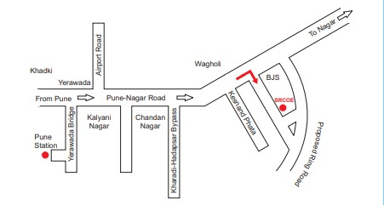
Send Your Manuscript :icatamse2024@gmail.com, Dates of Conference : 22nd -23rd –March-2024

