Faculty Details
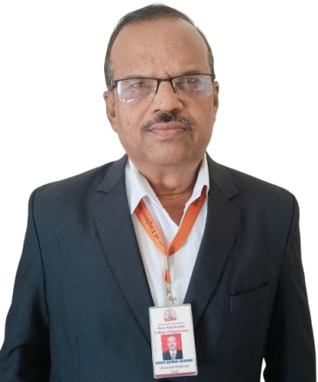 | Email: bhimraoborude73@gmail.com
  Prof. B. G. BORUDE.
  HOD
  Qualification : M.E Civil
  Specialization : Geotechnical Engineering
  Experienece : 34 Years
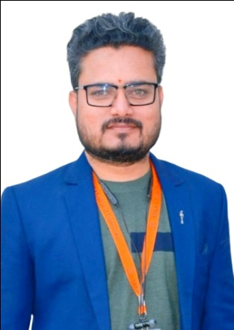 | Email: 5994asc@gmail.com
  Prof. A. S. CHOURE.
  Lecturer
  Qualification : M.E Civil
  Specialization : Structural Engineering
  Experienece : 08 Years
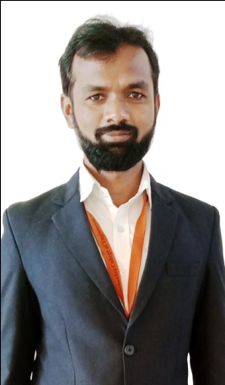 | Email: arunraykar1@gmail.com
  Prof. A. Z. Raykar.
  Lecturer
  Qualification : M.E Civil
  Specialization : Structural Engineering
  Experienece : 08 Years
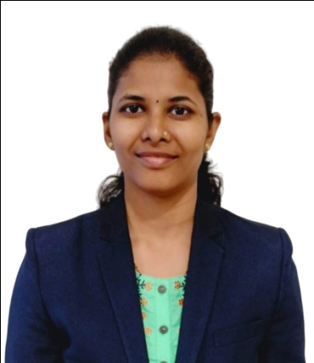 | Email: snehalbankar13@gmail.com
  Prof. S. N. Bankar.
  Lecturer
  Qualification : M.E Civil
  Specialization : Structural Engineering
  Experienece : 05 Years
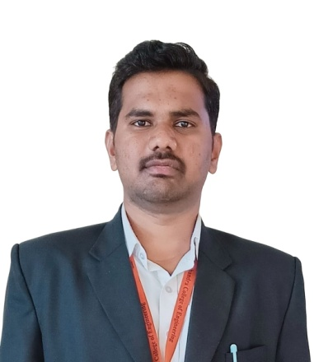 | Email: shubhamfulsoundar27@gmail.com
  Prof. S. D. Fulsoundar.
  Lecturer
  Qualification : M.E Civil
  Specialization : Structural Engineering
  Experienece : 03 Years
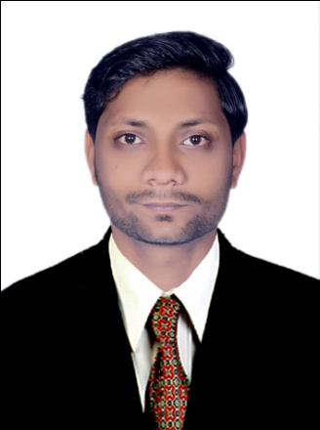 | Email: sanketborole8@gmail.com
  Prof. S. D. Borole
  Lecturer
  Qualification : B.E Civil
  Specialization : Civil
  Experienece : 03 Years

